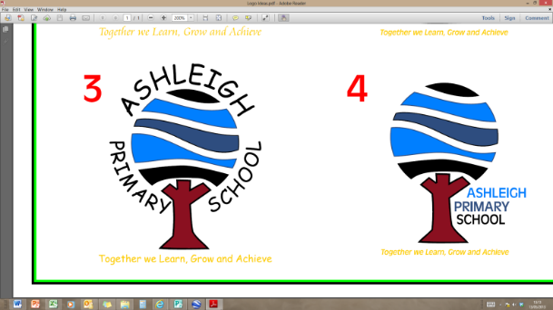Teaching & Learning Assistant Level 2

Person Specification

|  |  |  |
| --- | --- | --- |
| Qualifications | Essential | Desirable |
| Good numeracy/literacy skills, GCSE or equivalent Grade C+ in Maths and English | ✓ |  |
| NVQ 2 Teaching Assistant or equivalent |  | ✓ |
|  | | |
| Experience |  |  |
| Working with young children | ✓ |  |
| Working in an educational setting | ✓ |  |
| Working with children with SEND |  | ✓ |
|  | | |
| Knowledge |  |  |
| Child development | ✓ |  |
| Language development | ✓ |  |
| Behaviour management techniques | ✓ |  |
| Awareness of SEND |  | ✓ |
|  | | |
| Skills and abilities |  |  |
| Ability to work with others as part of a team towards a common goal | ✓ |  |
| Good communication skills | ✓ |  |
| Ability to modify/adapt teaching materials | ✓ |  |
| Creation of resources | ✓ |  |
| Monitor and evaluate progress | ✓ |  |
| Record keeping | ✓ |  |
|  | | |
| Attitude |  |  |
| Develop a positive relations with child/children | ✓ |  |
| Be positive to the social/emotional/educational integration of the child/children | ✓ |  |
| Be sensitive and responsive to child’s/children’s needs/feelings/mood | ✓ |  |

June 2017