Year 2 - Homework Grid – Autumn Term 2024
Spelling Challenge  Make sure you know how to spell all the Year 1 common exception words (see list) as well as practicing your spelling every week. If you know the Year 1 words start learning the Year 2 words.  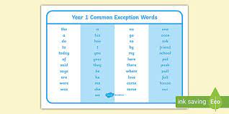 | PE Challenge  How many times can you throw and catch a ball in a row? Can you beat your score?   | Maths Challenge  Make sure you can write your numerals the correct way.  Learn your number bonds to 10 and then to 20 so you know them off by heart. I have set some games on Purple Mash to help you with this. | Science Challenge  Choose a microhabitat – this could be a rock, log, plant, a pile of leaves, grass ect…- and record what minibeasts you can find.  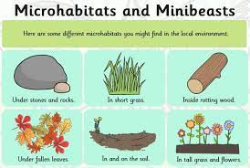
Date completed: | Date completed: | Date completed: | Date completed:
DT Challenge  Investigate how much sugar is in different drinks. You could use the NHS Food scanner app to help with this. What is a healthy drink choice? What is an unhealthy drink choice?   | Writing Challenge  Write three sentences on any subject that interests you. Make sure you include capital letters, full stops, finger spaces, correct letter formation and good spelling.  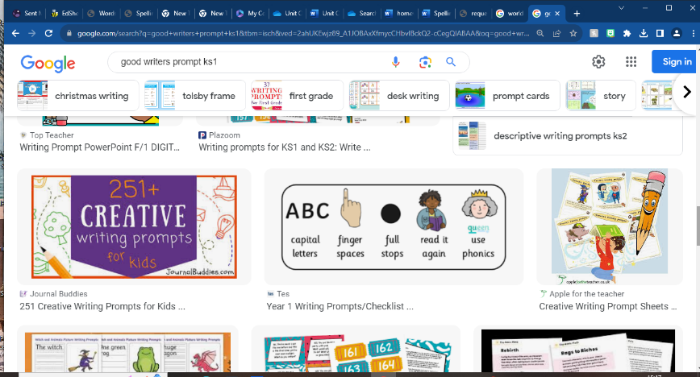 | Geography Challenge  Locate Darwen on a map. Write a list of 5 things you can see in Darwen.  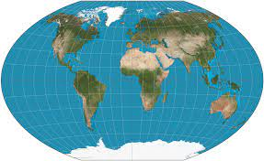 | ICT Challenge  Draw a poster that shows how you can stay safe when using ICT.  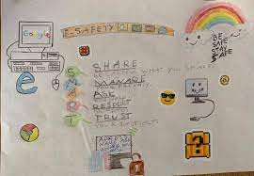
Date completed: | Date completed: | Date completed: | Date completed:

