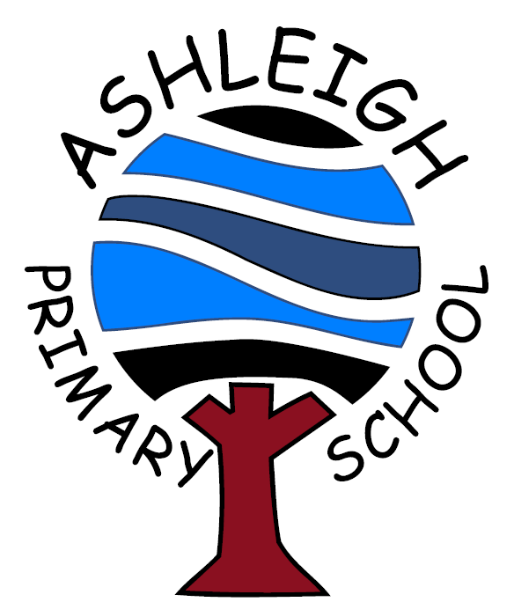

Ashleigh Primary School
Ross Street,
Darwen,
Lancashire.
BB3 2JT
Phone: 01254-703171
Email: office@ashleigh.blackburn.sch.uk
Web Address: www.ashleighdarwen.co.uk
Headteacher: Mr I Matthews B.Ed. (Hons), N.P.Q.H.
Acting Deputy Headteacher: Mr M. Harty B.A. (Hons)

Together we Learn, Grow and Achieve

Star of the Week Winners
Friday 10th May 2024

Reception  (Rabbits) | Maddox Porter  Super Phonics | Jason Whitaker  Excellent repeating patterns
Year 1  (Bears) | Oliver Slade  For a great week in Year 1 | Leo Wearing  Showing perseverance
Year 1 / Year 2  (Bees) | Nathan Lawless  For a mature attitude in class | Willow Barnes  For being an excellent friend
Year 2  (Peacocks) | Luca Jones  Being ready to learn | Reggie Duerden  Great sewing
Year 3  (Frogs) | Max Ingham  Egyptian art | William Phipps  Egyptian art
Year 4  (Elephants) | Holly Fox  Amazing 3D effect painting | Roshan Nawaz Bentayeb  Writing about Henry’s Freedom Box
Year 5  (Dolphins) | Klaudia Lici  Trying in all subjects | Charlie Bury  Trying hard in maths
Year 6  (Giraffes) | Grace Edwardson  Wonderful focus all week | Anqi Bury  Always being ready to learn

