Ashleigh Primary School

Pandemic Flu

Policy

Reviewed: March 2017
Staff: __________
Approved by Governors: __________
Review date: March 2019

British Values
Through its curriculum, extra-curricular activities, teaching and learning this school will promote British values. By doing so, we will ensure that all learners understand the values that have traditionally underpinned British society. The teaching of these values will promote cohesiveness within our school and community. We will prepare pupils for life in England where the population has an increasingly rich diversity of backgrounds, origins, beliefs and cultures by promoting the values on which our society has been built. By teaching pupils these values we will help all to become good citizens of the United Kingdom of Great Britain and Northern Ireland.

Race Equality and Racial Harassment
Implicit in all our policies is a belief in race equality and everything will be done to promote this. We do not tolerate racial harassment. (Refer to School’s Race Equality and Racial Harassment Policies).

Background
It is impossible to predict when the next pandemic might occur or how severe its consequences might be. On average, three pandemics per century have been documented since the 16th century, occurring at intervals of 10 - 50 years. In the 20th century, pandemics occurred in 1918, 1957 and 1968. The pandemic of 1918 is estimated to have killed more than 40 million people in less than a year, with peak mortality rates occurring in those aged 20 - 45 years. The pandemics of 1957 and 1968 were milder with 1 - 4 million estimated deaths primarily in traditional groups such as the elderly, but many countries nevertheless experienced strains on health-care resources. If an influenza pandemic virus were to appear again similar to the 1918 strain, even taking account of recent medical advances, unparalleled tolls of illness and death could be expected. Air travel would hasten the spread of transmission of the virus and decrease the time available for preparing intervention. Although it is not considered to feasible to halt the spread of a pandemic virus, it should be possible to minimize its consequences through advance preparation. This note, which will be reviewed and re-issued annually, sets out guidelines in the event of a pandemic together with the school's policy in relation to the control and prevention of flu-like symptoms as a matter of routine.

The World Health Organisation (WHO)
The WHO constantly monitors the various flu-type viruses that emerge each year and categorises the development of each within five defined phases, with particular concern where there is evidence that a virus that emanated in animals or birds has become adapted to humans. Advice will also be issued through the ISBA, MOSA and the Pandemic Influenza Planning Group established in the Health Protection Agency.

Planning Assumptions.
Advice to all sectors from the Local Authority is that they should seek to continue operating as normally as possible during a pandemic, but should plan for much higher than usual levels of staff absence and the consequences as well as for other possible disruption resulting from the pandemic's impact on other services. However, schools are potentially different from other settings. Children are highly efficient "spreaders" of respiratory infections, amongst themselves and to adults. There is some evidence that such infections spread less amongst children in holiday periods than in term-time. Thus, closing school for a period might reduce significantly the number of children infected. Once the nature of any future pandemic is detected, the Government may advise schools to close for a stated period. Our response to any pandemic should cover both closure and the school remaining open. The Strategic Director of Children’s Services will communicate the Government’s message to schools locally.

The School's Response
To help prevent the occurrence of an outbreak, infection control will be promoted. Any new guidance received from the Government will be circulated to school by Children’s Services when received. School will remind staff and pupils of the importance of handwashing in helping to reduce the spread of disease. If necessary, the Headteacher and Senior Leadership Team will co-ordinate the school's response which will be graduated according to what may be a quickly changing scenario. Unless directed to close, the aim will be to conduct business as normal within the following:
- The school does not have the facilities to treat those suffering from influenza. Staff feeling unwell or displaying symptoms such as a high temperature will be sent home immediately. Similarly, pupils will be collected at the first opportunity by their parent(s) or guardian. School must retain an up-to-date list of guardians; in turn, there is a clear duty on parents to ensure that they have a full understanding of the school's policy and their possible involvement.
- Pupils and staff deemed to be at high risk due to pre-existing conditions should be advised to stay at home for all or part of any pandemic.
- Central Government, through the local authority, will advise on any mandatory closure of the school when pupils and staff would be sent home. Should local conditions, such as general shortages of food, the disruption of power supplies, or insufficient staff to ensure the proper supervision or first-aid medical care for pupils occur, the Headteacher will inform the Chair of Governors accordingly and order closure.
- The Senior Leadership Team will manage academic staff absences on a daily ad hoc basis making best use of available staff.
Infection Control
As a matter of course during the traditional "flu season" from Nov - Mar, pupils and staff should be actively encouraged by staff to minimise potential influenza transmission through good hygiene measures as follows:
- By covering the nose and mouth with single-use disposable tissues when sneezing, coughing, wiping and blowing noses.
- By disposing of used tissues in the nearest waste bin.
- By keeping hands away from the mucous membranes of the eyes and nose.

Cleaning and Waste Disposal

General
The Catering Manager and Site Supervisor are to adopt as appropriate the following measures to improve general hygiene as a matter of course:
- All hard surfaces in kitchens, door handles, telephone headsets, toilet seats and flushes are to be wiped over with an approved, chlorine based anti-septic solution on a daily basis (Milton).
- Waste bins are to be emptied on a daily basis with the contents being sealed in plastic bags prior to disposal.

Pandemic.
- If and when instructed by the Headteacher, all cleaning staff are to be issued with medicated face-masks which are to be worn when employed on cleaning duties.
- The Site Supervisor is to ensure that receptacles containing sealable plastic bags are deployed around the school for the collection of used paper tissues. They are to be emptied on a daily basis and disposed of in sealed plastic bags: if practical, they should be burnt.

Pre-stocking
The Site Supervisor is to hold stocks of latex gloves, medicated face masks and suitable plastic bags. Perishable stocks are to be turned-over on a regular basis.

Conclusion
It is difficult to determine in advance the likely consequences for the school in the event of a major pandemic. The school should continue to function unless instructed to close or in the event of local conditions making continuation impossible or unsafe. Flexibility would be required by all staffs, with due emphasis at all levels being given to minimising the risk through good and responsible personal and general hygiene.

Appendix A - Influenza Pandemic – General Public Health Messages

Please note that this is based on information provided by the Government as at April 2007 and is for guidance purposes only and is not intended as a substitute for seeking advice and diagnosis by a medical professional.
In this document “Flu” relates to a new strain of influenza that is the cause of a pandemic. It does not refer to seasonal influenza.

What practical steps can you take?

If you catch flu:
- Stay at home and rest.
- If you plan to take medicines, check with a medical practitioner.
- Drink plenty of fluids.

You can reduce, but not eliminate, the risk of catching or spreading flu during a pandemic by:
- Covering your nose and mouth when coughing or sneezing.
- Using tissues and disposing of dirty tissues promptly and carefully – bag and bin them.
- Avoiding non-essential travel and large crowds wherever possible.
- Maintaining good basic hygiene, e.g. washing your hands frequently with soap and water to reduce the spread of the virus from you hands to your face, or to other people.
- Cleaning hard surfaces (e.g. kitchen workshops, door handles, light switches) frequently, using a normal cleaning product.

What is a flu pandemic?

A pandemic occurs when an influenza virus subtype emerges, or re-emerges, that is:
- Markedly different from recently circulating strains.
- Able to infect people.
- Readily transmissible from person to person.
- Capable of causing illness in a high proportion of those infected.
- Able to spread widely because few, if any, people have natural or acquired immunity to it.

When will it occur and who will be affected?

- No one knows exactly when a flu pandemic will occur.
- Unlike seasonal flu, which happens during the winter, a flu pandemic could occur at any time of the year.
- When it does arrive, it may come as a single wave, or in 2 or more waves several months apart.
- Each wave may last 2 to 3 months across the UK as a whole.
- Once the pandemic arrives, it is likely that it will spread throughout the UK rapidly, possibly in a matter of weeks rather than months.
- No one knows how severe it will be.
- No one knows whether it will hit specific groups more severely, or whether it will affect the whole population indiscriminately.

How does it spread?

- By the respiratory route, i.e. when an infected person coughs, sneezes or talks they produce droplets of infected respiratory secretions. The finer the droplet, the longer they stay in the air and the more effective they are at spreading the infection.
- By hand to face contact after a person or surface contaminated with infectious respiratory droplets has been touched.

When are people infectious?

- Some people may be infectious to others between 1 to 2 days before the onset of symptoms.
- Most people, however, are highly infectious for 4 to 5 days from the onset of symptoms, but this can be longer in children and people who are immuno-compromised.
- Children have been shown to shed virus for longer (up to 7 days from onset of symptoms) & at higher levels than adults.
- Some people can be infected without showing any symptoms, but can still shed the virus and be able to pass on the infection.
- The incubation period is in the range 1 to 4 days, & typically 2-3 days.

Signs and symptoms of influenza

Most significant: Other symptoms include:
Fever Aching muscles
Headache Sore throat
Cough or shortness of breath Runny nose, sneezing
Malaise Loss of appetite
Sudden onset of illness
Chills

Key messages to the public are:

Stay at home
Don’t spread it about

Appendix B – List of WHO pandemic phases and UK ALERT LEVELS (used internationally, the higher the level of alert, the more serious the situation) 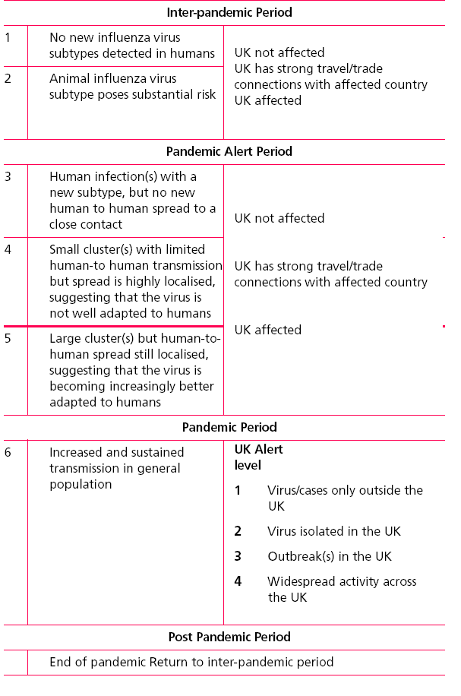
Reviewed: March 2017
Staff: __________
Approved by Governors: __________
Review date: March 2019

Chair of Governors: _________________ Date: _________________

Headteacher: _____________________ Date: ____________________

